**Practiccal : 9 with assignment: 11**

* **Aim :** Create a swap area of 512 MB on your machine and delete it.
* **Code with output :**
* To make the swap file

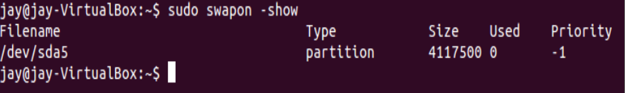

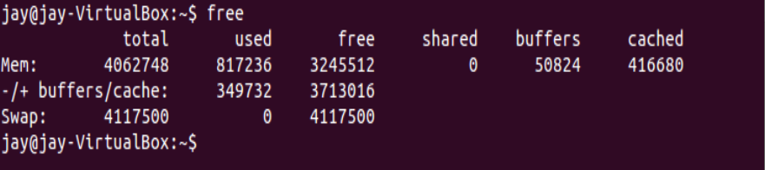



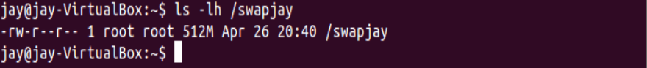



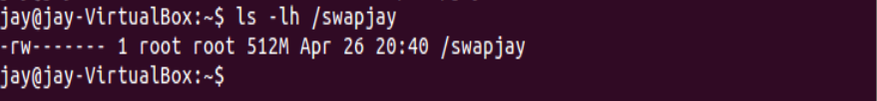

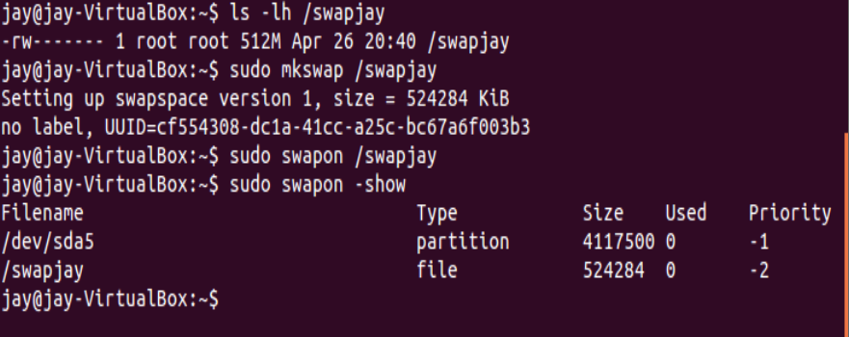



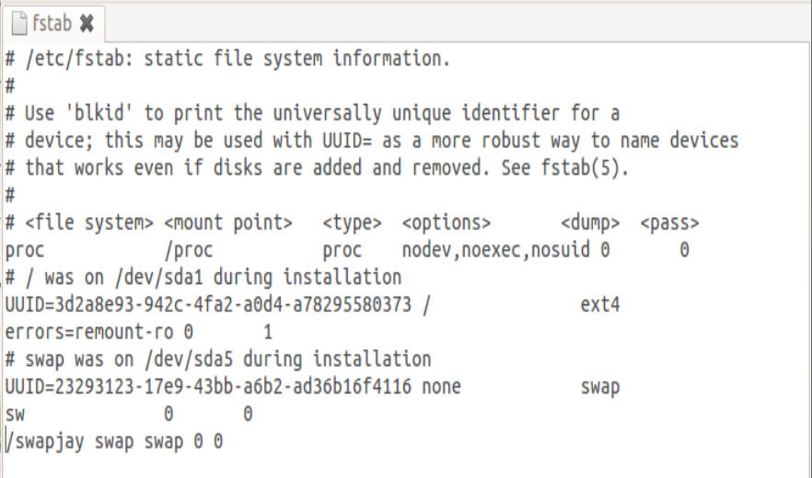

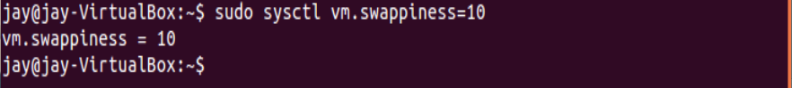

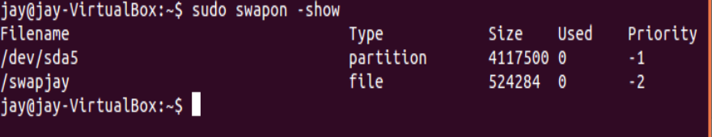

* To delete the swap file

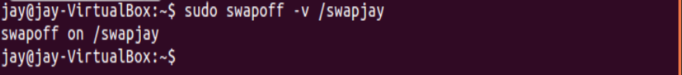

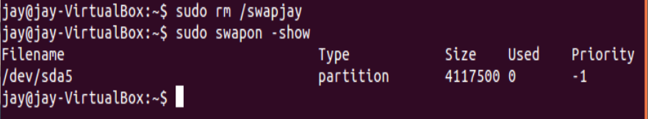

**Practiccal : 10**

* **Practical : 10(a)**
* **Aim :** Create a file and check the following information for it’s inode.
* **Code and output :**

1. check inode number of that file



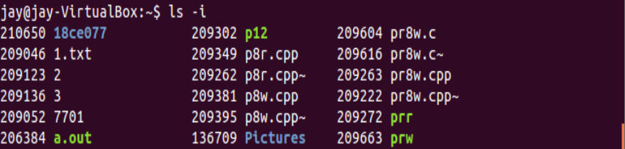

2. search the file using its inode number.

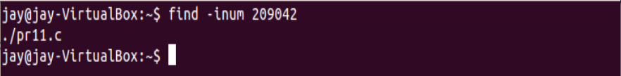

3. Find the total number of inodes in the system. (stat , -i , tune2fs)

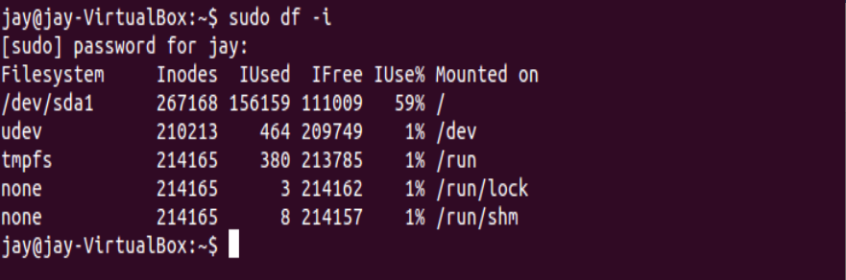

4. List all the statistics about inode usage (amount available, amount used and amount free and use percentage)



5. Check total number of free inodes.



6. Check total number of used inodes.



7. Find inode utilization in the current directory.

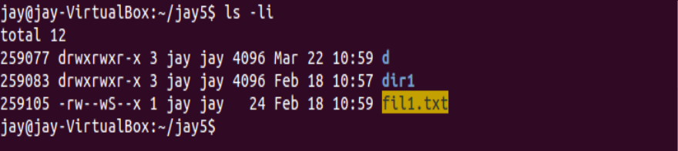

8. Count Inode Usage with Grand Total

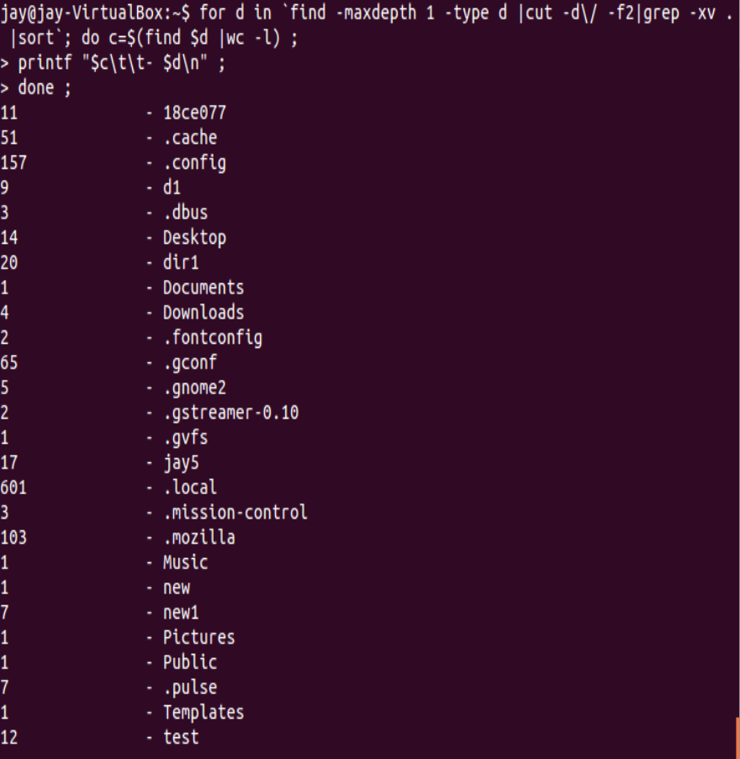



9. Does inode change when you copy and move the file?

Moving is actually creating a copy of a file in a new location, then deleting the file from its previous location. Since it is impossible to have two identical inode numbers at the same time, the inode number should change after copying and before deleting the old file (short time).

* Before copy file

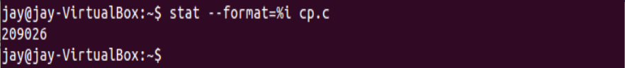

* After copy file in other folder

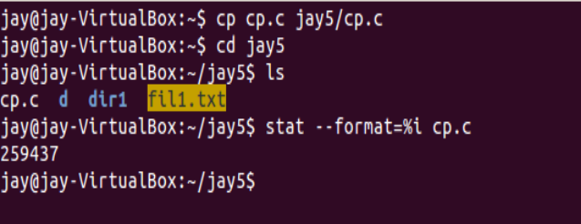

10. Can we reduce inode usage?

* Deleting the old emails helps a lot in decreasing the inode usage. There might be spam mails in your mailbox which are of no use and deleting those mails will hep you to reduce the inode number. You can remove spam emails from email client or webmail.

11. Does the total number of inode depend on system configuration or flavours of Linux/Unix operating system?

* The total number of inodes and the space reserved for these inodes is set when the filesystem is first created. The inode limit can't be changed dynamically and every file system object must have an inode.

12. Specify size of inode. Does every inode have the same size?

* mke2fs creates 256-byte inodes by default. In kernels after 2.6. 10 and some earlier vendor kernels it is possible to utilize inodes larger than 128 bytes to store extended attributes for improved performance. The inode-size value must be a power of 2 larger or equal to 128.
* The inode itself holds file metadata and not any data. As such, it doesn't matter if the size is small or large. ... For Linux/Unix systems, the filesystem has to be able to provide a minimum set of information in the inode but filesystems can store more than that internally, both on the disk an in memory.
* **Practical : 10(b)**
* **Aim :** Understand Superblock.
* **Code and output :**

1. List the contents of the filesystem superblock

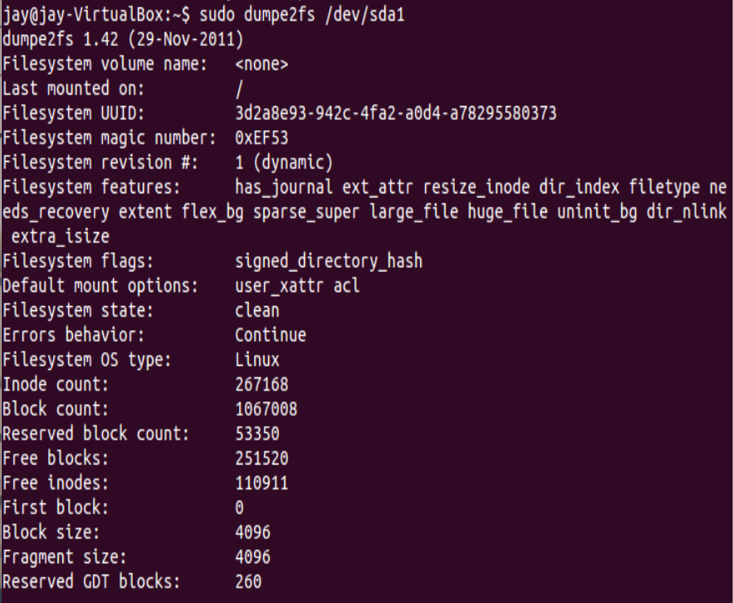

1. Manipulate the filesystem meta data

* You can see the contents of an inode as it exists on an Ext4 file system with debugfs command.  You need to use the stat command that is available in the file system debugger to show the contents of the inode. When done, use exit to close the debugfs environment.

Make sure files on the file system cannot be accessed while working in debugfs. You should consider remounting the file system using mount -o remount /yourfilesystem

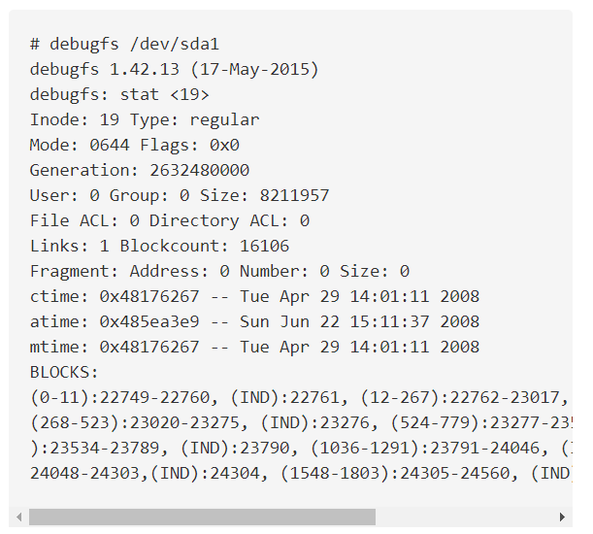

* **Practical : 10(c)**
* **Aim :** Create hard link and soft link for a file
* **Code and output :**

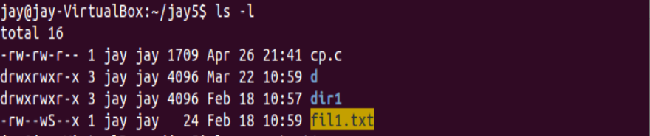

* Create hard link for file

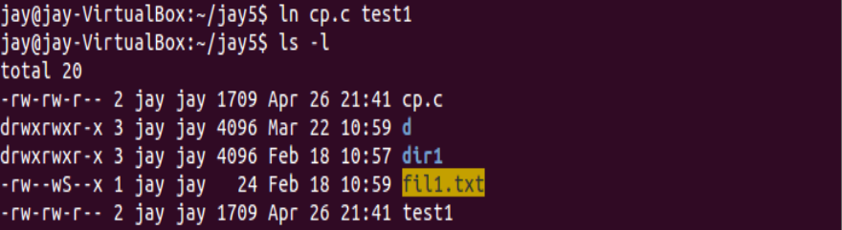

* Create soft link for file

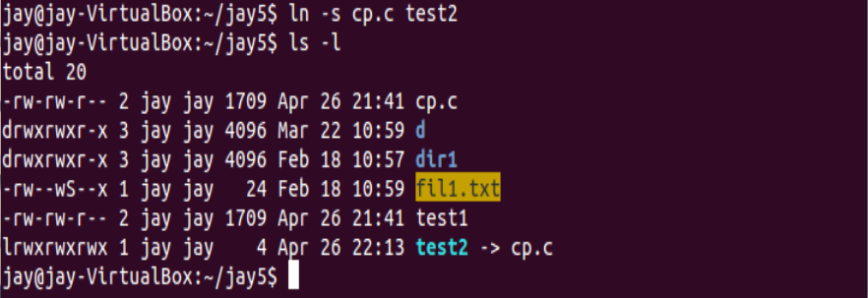

* **Practical : 10(d)**
* **Aim :** Find hard link in Linux
* **Code and output :**



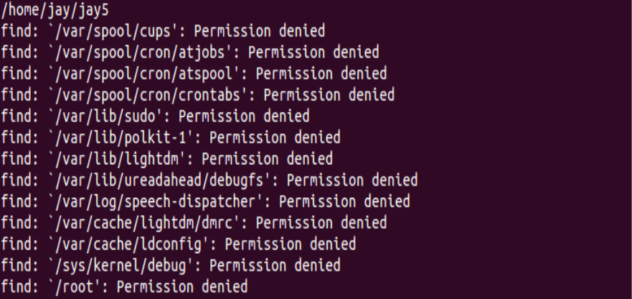

**Assignment: 12**

* **Aim :**

Mention any five information about superblock and inode (practically) which is not covered in practical task.

* **Super Block :**

1. The block size is something that can be specified when a user formats a partition using the command line parameters available.

mkfs -t ext3 -b 4096 /dev/sda1

In the above command we have specified block size while formatting /dev/sda1 partition. The size specified is in bytes. So basically one block will be of 4096 bytes.

1. You can also view the exact locations of superblock and backups using the same dumpe2fs command as shown below.

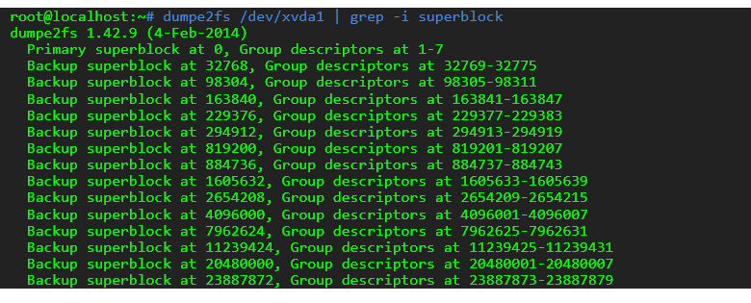

* **Inode :**

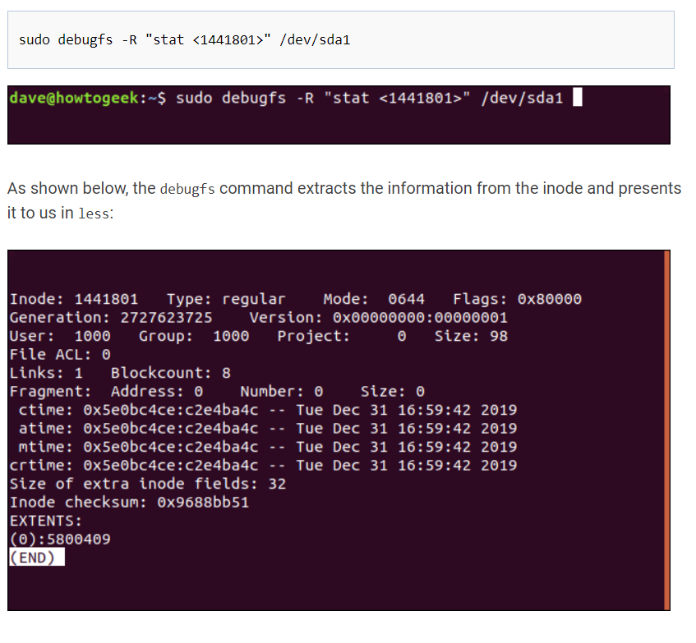

1. A quick way to examine an inode in AIX is by using the istat command. With this command, you can find the inumber of the specific file as well as other inode items like permissions; file type; UID; GID; number of links (not symbolic links); file size; and time stamps for last updated, last modified, and last accessed.

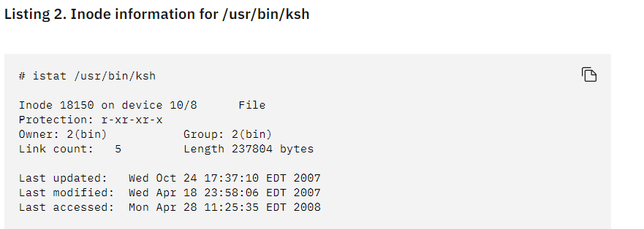

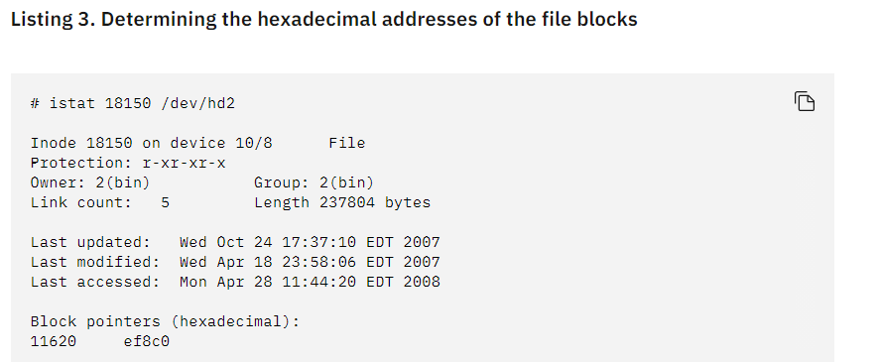

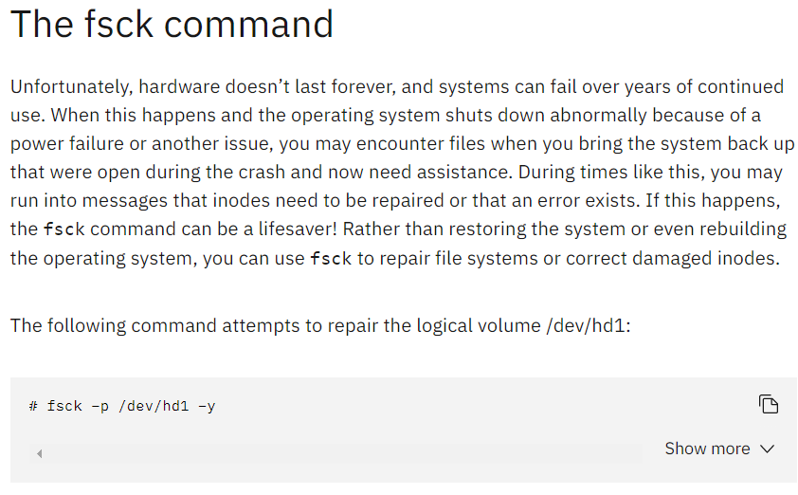

Conclusion :

In this practical we have learned about swap file and also create and delate swap file in linux , also learned about inode and super block in linux os and perform command to get the information about inode / superblock .